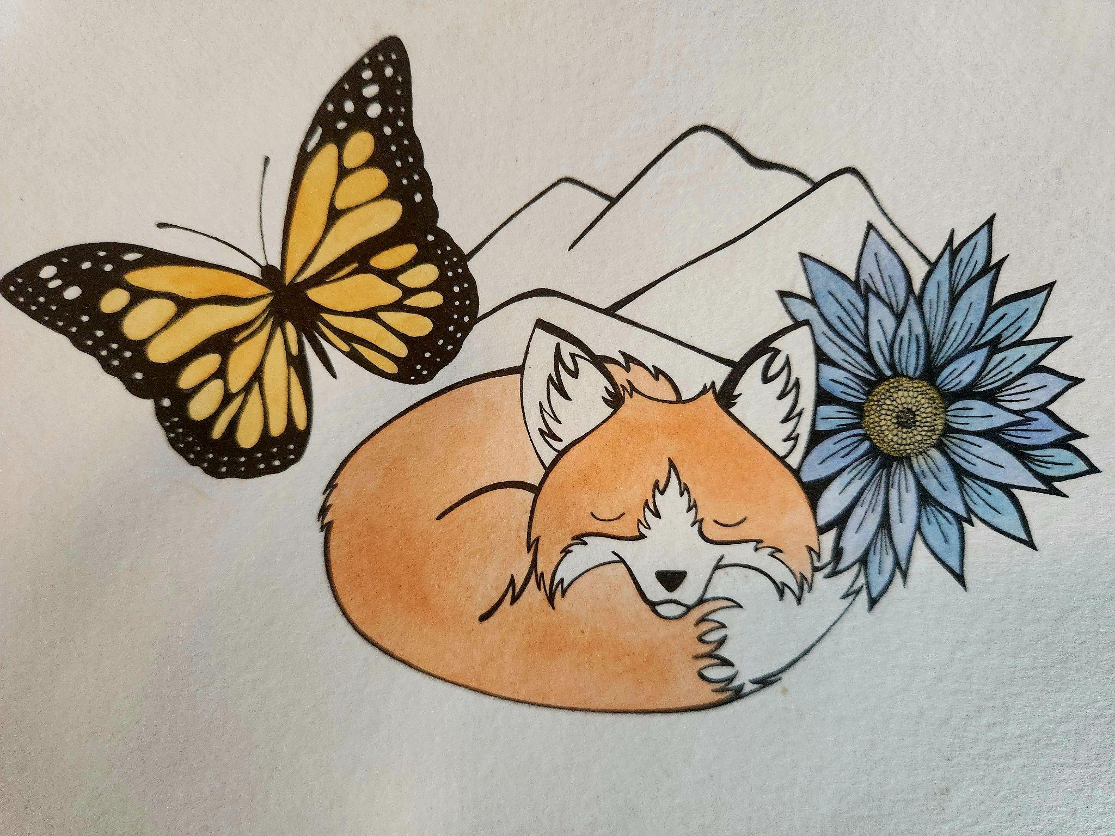
LITTLE FOX LEARNING CENTER
*SUMMER 2026 HOURS & TUITION RATES*
For children ages 4-12

Hours: Monday through Friday 7:45 am to 6:00 pm

*A $50 registration fee is due at the time of registration and will be used towards summer supplies. A non-refundable deposit of $100 per child will be required but will be put towards first month’s tuition.

SUMMER SCHEDULE FOR:

_____________________________ _____
Child’s Name Age

________________________________________ _______
Child’s Name Age

PLEASE NOTE: The below activities are only ADDITIONAL activities each week. No matter what the theme, we will offer multiple outdoor/creative activities to fit the interests and needs of each child and age group. For instance, if your kiddo does not love sewing, they will have a multitude of activities to choose from no matter what day they attend. Between hiking, field trips and swimming, there is so much to choose from each week/day.
MY CHILD(REN) WILL BE ATTENDING: Use an x next to the days/weeks attending
WEEK 1: Introduction to the farm, getting to know camp counselors and fellow campers.
- June 10 $55
- June 11 $55
- June 12 $55
WEEK 2: Continue introductions, gardening, learning how to feed and care for animals.
- June 15-19 $275
WEEK 3: Identifying plants, trees, summer weather patterns, hiking basics, basic first aid class.
- June 22-26 $275
WEEK 4: Bats, birds and insects; build bird houses/bee boxes/bat boxes.
- June 29 $55
- June 30 $55
- July 1 $55
WEEK 5: Basic cooking classes, recipe books, nutrition, edible plants
- July 6-10 $275
WEEK 6: Basic sewing, thrifting for fabrics/craft supplies
- July 13-17 $275
WEEK 7: Basic building class, painting, sanding, tool safety.
- July 20-24 $275
WEEK 8: Fort building, free choice of weekly studies, finish projects
- July 27-31 $275
WEEK 9: Music and theatre week, costume design, trying out instruments
- August 3-7 $275
WEEK 10: Map skills/making, geocaching, safety in the woods.
- August 10-14 $275
WEEK 11: Camping skills, learning about gear, set up camp, fire safety and cooking over a campfire. August 20 & 21 are overnight camps at Little Fox. August 21 will be the end of summer bbq for all families to join. 2pm-6pm
- August 17-21 $275
- August 20 overnight camp $20
- August 21 overnight camp $20
WEEK 12: Finish out summer with our favorite things, make postcards, address books for camp penpals; finish memory/photo books.
- August 24 $55
- August 25 $55

LITTLE FOX SUMMER PROGRAM
Child Registration Form

Child’s Name:______________________ DOB: ____________ Age:______ Grade entering: _____

Child’s Name:________________________ DOB: ____________ Age:______ Grade entering: _____

ELEMENTARY SCHOOL: ________________________________

MOTHER/GUARDIAN NAME:_______________________________________________
Address: __________________________________________________________________
Street/PO BOX City State Zip Code

Telephone #: CELL: _________________
*PREFERRED METHOD OF CONTACT: (LIST IN ORDER FROM FIRST CONTACT PREFERENCE TO THIRD) _____Mother First ____Father First
____TEXT TO CELL _____PHONE CALL TO CELL _____PHONE CALL TO WORK #_________________________

Email Address: *PLEASE LIST ONE PREFERRED EMAIL ADDRESS FOR ALL CORRESPONDENCE FROM LITTLE FOX
_________________________________________________________________

Employer: _________________________________________________________________ Business Name Address Phone #

FATHER/GUARDIAN NAME: ___________________________________________
Address: __________________________________________________________________
Street/PO BOX City State Zip Code

Telephone #: CELL: _________________
*PREFERRED METHOD OF CONTACT: (LIST IN ORDER FROM FIRST CONTACT PREFERENCE TO THIRD)
____TEXT TO CELL _____PHONE CALL TO CELL _____PHONE CALL TO WORK #_________________________

Email Address: *PLEASE LIST ONE PREFERRED EMAIL ADDRESS FOR ALL CORRESPONDENCE FROM LITTLE FOX
_________________________________________________________________

Employer: _________________________________________________________________ Business Name Address Phone #

HEALTH INFORMATION:
Physician:
______________________________________________________________________________
Name Address Phone #

**ALLERGIES/MEDICAL CONDITIONS/SPECIAL NEEDS/DIETARY RESTRICTIONS:

______________________________________________________________________________

_____________________________________________________________________________

**LEARNING DISABILITIES/SPEECH OR LANGUAGE ISSUES/BEHAVIOR RELATED DIAGNOSES/CONCERNS:
_____________________________________________________________________________

______________________________________________________________________________

This form contains Terms of Agreement as an additional sheet, and forms a binding contract once signed/initialed.

I/We acknowledge that we have read the Terms of Agreement and consent to the same and warrant the information set out above is true and correct.

I/We give permission for our child to attend Little Fox Learning Center to and to partake in field trips, consuming snacks and food that the Center provides, and riding the Little Fox Bus to field trips in Helena and the surrounding area.

______________________________________________________________________________
Parent/Guardian Signature Date

______________________________________________________________________________
Parent/Guardian Signature Date

Registration fee paid in the amount of $50 per child ______ Date:__________

Summer deposit paid in the amount of : $100 per child______ Date: __________

LITTLE FOX LEARNING CENTER, LLC

It is hereby agreed that the parents of
__________________________________________ will: (Please initial each line to show that you agree with all stipulations.)

- _____ Pay all of the fees, at all times, as applicable, in advance or by the due date as agreed upon, which is the 1st of each month the child will be attending. (For example, June tuition is due on June 1st, July is due on July 1st, etc.) Cash, check or venmo will be accepted.
Tuition paid after the 5th of each month will incur a $25 late fee for the first day late and a $5 late fee each day after the 5th. If payment is not received by the 10th, care will be suspended until payment or payment arrangement is made. Split payments require a signed contract which will be given upon meeting with the director before this plan can be put in place. Consistently late payments can result in termination of care at any time.

- _____ Notify the Center of any infectious disease your child might come into contact with and keep the child home for the required period prior to allowing the child to return to the Center. A doctor’s note may be necessary depending on the illness. Children with fevers of 99 degrees or higher, vomiting for any reason, diarrhea and cases of lice cannot attend school until a 24-hour period has passed without any symptoms/signs of those illnesses. If your child has a cough, runny nose or other cold symptoms lasting longer than 3 days the Center reserves the right to discontinue care until the sickness has passed.

- _____ Notify the Center immediately of any change of address, phone number, or any other enrollment information that might occur for either parent. Failure to do so can interfere with communication, billing, etc.

- _____ Notify the Center of any and all allergies, medical conditions, special dietary needs, behavior problems or special needs, speech delays, and learning disorders so that the Center may give the utmost care and attention to these needs, or determine whether or not the Center is able to tend to those needs.

It is further agreed as follows:

- _____ The Center shall not be responsible or any lost items or damage to the clothing or property of the child while the child is in attendance at the Center or participating in the program. We will make every effort to keep track of personal items as well as to teach the child how to maintain and care for his/her personal items. We will keep a lost and found at all times.

- _____ Parents agree to ensure that child has the appropriate gear and supplies each and every day. Every day child needs to have: WATER BOTTLE, APPROPRIATE SHOES, SUN SCREEN (APPLIED EVERY MORNING), BACK PACK FOR GEAR, COMFORTABLE/OUTDOOR CLOTHING. On swim days each child must have: SWIM SUIT/TRUNKS, TOWEL, SUN SCREEN. . Water bottles can be left at Little Fox to ensure the child has one each day. Please label ALL ITEMS. Please see the handbook for more details.

- _____ Should any occasion arise requiring the child to be taken to the hospital for emergency treatment of any kind and for any reason irrespective of cause, and contact with the parent has not been possible, your permission to act as temporary guardian is required by the Center in order to avoid any delay in such treatment being received, on the understanding that the Center will be held blameless from any situation arising from such treatment.

- _____ No amendment of the terms of this agreement shall be binding unless consented by the Center and the Parent/Guardian in writing.

I have read this contract in its entirety and agree to all of the terms listed above.
I have read and understand the payment policy, tuition due date policy, termination of care (by provider and by families) policy’s, and late fee policy’s.

Signed: ________________________________ Date: __________________

Signed: ________________________________ Date: __________________

